**Haiti Money Remittance Location Analysis**

# **Introduction**

## **Background**

The **Republic of Haiti** is a country located on the island of Hispaniola in the Greater Antilles archipelago of the Caribbean Sea, to the east of Cuba and Jamaica and south of The Bahamas and the Turks and Caicos Islands. It occupies the western three-eighths of the island which it shares with the Dominican Republic. Haiti is 27,750 square kilometers (10,714 sq mi) in size, the third largest country in the Caribbean by area, and has an estimated population of 11.4 million, making it the most populous country in the Caribbean.

Historically poor and politically unstable, Haiti has the lowest Human Development Index in the Americas. Since the turn of the 21st century, the country has endured a *coup d'état,* which prompted a U.N. intervention, as well as a deadly earthquake that killed over 250,000.

Administratively, Haiti is divided into ten departments. The departments are listed below, with the departmental capital cities in parentheses.

1. Nord-Ouest (Port-de-Paix)
2. Nord (Cap-Haïtien)
3. Nord-Est (Fort-Liberté)
4. Artibonite (Gonaïves)
5. Centre (Hinche)
6. Ouest (Port-au-Prince)
7. Grand'Anse (Jérémie)
8. Nippes (Miragoâne)
9. Sud (Les Cayes)
10. Sud-Est (Jacmel)

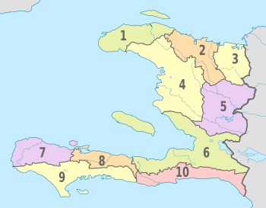

*The CIA World Factbook* also states that **"remittances are the primary source of foreign exchange, equaling one-fifth (20%) of GDP and representing more than five times the earnings from exports in 2012".**The World Bank estimates that over 80% of college graduates from Haiti were living abroad in 2004.

## **Problem**

As mentioned in the Background section Money Remittance is one of the main sources of income for Haiti. Based on this fact, it’s important to identify areas of opportunity to open Money Remittance locations in strategic areas that can comply with the demand for this type of service.

# **Data**

Based on the problem described several data source will be used for this project:

* Data of current locations obtained from one of the remittance company providers (private source) which will be used to understand which areas already have money remittance locations nearby.
* Foursquare API to obtain information on venues for the different Haiti departments for the analysis of possible locations opportunities.
* Wikipedia to obtain data of population per city and department which will help to analyze areas of opportunity.